BOOLEAN ALGEBRA

OBJECTIVE:
- To verify experimentally some of the Boolean theorems.

THEORY:
Boolean algebra is the mathematics we use to analyze digital gates and circuits. We can use these “Laws of Boolean” to both reduce and simplify a complex Boolean expression in an attempt to reduce the number of logic gates required. Boolean algebra is therefore a system of mathematics based on logic that has its own set of rules or laws which are used to define and reduce Boolean expressions. The combinational logic circuits do not have the ability to memorize their past. The result is that combinational logic circuits have no feedback and any changes to the signals being applied to their inputs will immediately have an effect at the output.
PROCEDURE:
Boolean Theorems: Following Boolean theorems table mount a 7404 IC, a 7408 IC, and a 7432 IC on the circuit board. Connect VCC to +5 V and GND to power ground on each IC. To verify each theorem, connect the circuit for that theorem. Monitor the output with logic probe and also with LED.
EQUIPMENT / REQUIREMENT:
- 7404IC
- 7408 IC
- 7432 IC
- LED
- 0-5 VOLT DC Power Supply.

BOOLEAN THEORAM:

Idem potency | X + X = X X • X = X
Redundancy Law | X+X.Y
Double negation | = X
Commutative Law | X + Y = Y+X
Associative laws | X + (Y + Z) = (X + Y) + Z
Distributive laws | X (Y + Z) = XY + XZ
Absorption | X + XY = X
De Morgan's theorem | (X1 + X2 + X3.....) = X1 • X2 • X3.......  (X1 • X2 • X3.....) = X1 + X2 + X3.......

RULES OF BOOLEAN ALGEBRA
- X+0=X 7. X.X=X
- X+1=1 8. X.X= 0
- X.0=0 9. X.X=X
- X.1=1 10. X+XB=A
- X+X=X 11. X+XB=X+B
- X+X= X 12. (X+B)(X+C)=X+BC

Verify circuit by using IC’s on breadboard.
X | X+0 | X+1=1 | X.0=0 | X.1=1 | X+X=X | X+X'= X | X.X= X | X.X'= 0
0 | 0 | 1 | 0 | 0 | 0 | 1 | 0 | 0
1 | 1 | 1 | 0 | 1 | 1 | 1 | 1 | 0
Table 4.1

x | y | Z | X + (Y + Z) | X + XY | X+X.Y | x (x + y)
0 | 0 | 0 | 0 | 0 | 0 | 0
0 | 1 | 0 | 1 | 0 | 0 | 0
1 | 0 | 1 | 1 | 1 | 1 | 1
1 | 1 | 1 | 1 | 1 | 1 | 1
Table 4.2

CIRCUIT IMPLEMENTATION:

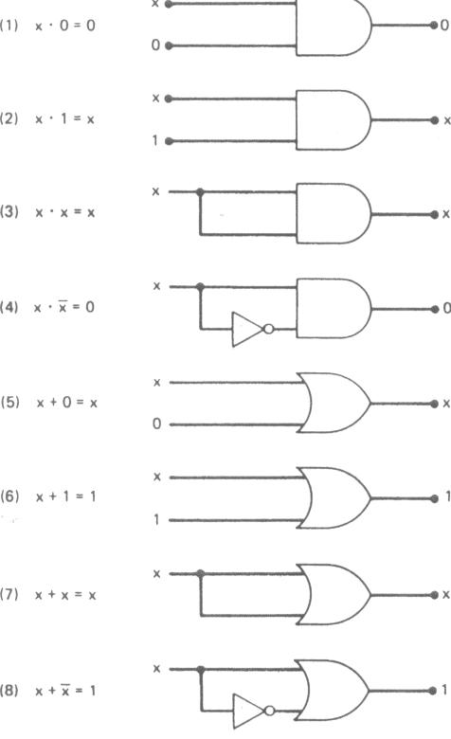

Task#1: Construct Circuit for Redundancy Law
Answer:
Equation for redundancy law is,
X+X.Y
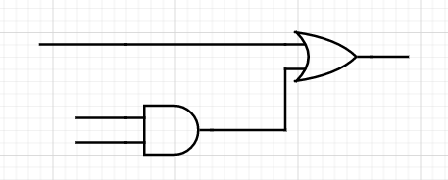
X (X+X.Y)

X (X.Y)
Y

Task#2: Draw logic diagram for x (x + y) and also find out the output x (x + y) =?
Answer:
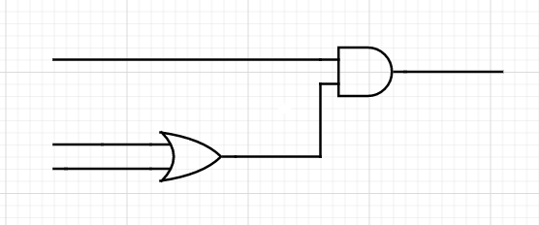
Given,
x.(x+y)
x x.(x+y)

x (x+y)
y

X | Y | (X+Y) | X(X+Y)
0 | 0 | 0 | 0
0 | 1 | 1 | 0
1 | 0 | 1 | 1
1 | 1 | 1 | 1

Task#3: Construct the circuit for Associative & Absorption theorems and observe the Output.
Answer:
Equation for Associative theorems is,
X + (Y + Z) = (X + Y) + Z
FOR LHS:
X | Y | Z | Y+Z | X+(Y+Z) (L.H.S)
0 | 0 | 0 | 0 | 0
0 | 0 | 1 | 1 | 1
0 | 1 | 0 | 1 | 1
0 | 1 | 1 | 1 | 1
1 | 0 | 0 | 0 | 1
1 | 0 | 1 | 1 | 1
1 | 1 | 0 | 1 | 1
1 | 1 | 1 | 1 | 1

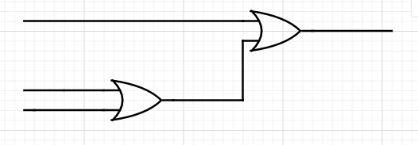
X X + (Y+Z)

Y (Y+Z)
Z
FOR RHS:
X | Y | Z | X+Y | (X+Y)+Z (R.H.S)
0 | 0 | 0 | 0 | 0
0 | 0 | 1 | 0 | 1
0 | 1 | 0 | 1 | 1
0 | 1 | 1 | 1 | 1
1 | 0 | 0 | 1 | 1
1 | 0 | 1 | 1 | 1
1 | 1 | 0 | 1 | 1
1 | 1 | 1 | 1 | 1

Z (X+Y) +Z

X (X+Y)
Y

Equation for absorption theorem is,
X + XY = X
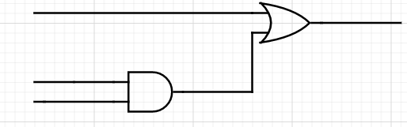
X | Y | XY | X+XY
0 | 0 | 0 | 0
0 | 1 | 0 | 0
1 | 0 | 0 | 1
1 | 1 | 1 | 1
X X + XY

X X.Y
Y

CONCLUSION:

Boolean Algebra is used to analyze and simplify the digital (logic) circuits. It uses only the binary numbers i.e. 0 and 1. It is also called as Binary Algebra or logical Algebra.
Following are the important rules used in Boolean algebra.
- Variable used can have only two values. Binary 1 for HIGH and Binary 0 for LOW.
- Complement of a variable is represented by an overbar (-). Thus, complement of variable B is represented as . Thus if B = 0 then = 1 and B = 1 then = 0.
- OR-ing of the variables is represented by a plus (+) sign between them. For example, OR-ing of A, B, C is represented as A + B + C.
- Logical AND-ing of the two or more variable is represented by writing a dot between them such as A.B.C. Sometime the dot may be omitted like ABC.

